**UPCOMING EVENTS**

**Jan. 13. …….………………...……. Book Club**

**Jan. 27 ...…Chili Supper, Meeting & Program**

**Feb. 10 ……………………………. Book Club**

**Feb. 18 ……… Hastings Reads Author speaks**

**HASTINGS BRANCH**

**Meets on Mondays**

**St. Philip’s Lutheran Church**

**1401 15th Street West,**

**Hastings, Minnesota 55033**

**2023-2024 PROGRAMS**

**September 23, 6:00 pm Salad Supper**

**Braver Angels**

**JoAnn Ward**

**October 28, 7:00 pm**

**Therapy Dogs: Biophilia and the Importance of Animal Kinship**

**Tanya Bailey & Maureen Kleckner**

**November 25, 7:00 pm**

**Women’s Work: Minnesota women’s contribution to the paid and unpaid economy**

**Christina Ewig, Univ of Minnesota Center for Women and Gender Public Policy**

**December 7, 10:00 am**

**Holiday Celebration at the Public House**

**January 27, 6:00 pm Chili Supper**

**Title IX: How has Title IX changed collegiate sports and games**

**Vicki Davis**

**February 24, 7:00 pm**

**Astronomer is for Everyone**

**Alex Grenbaum**

**March 24, 7:00 pm**

**The State of Dakota County**

**Dakota County Attorney Kathryn Keena**

**April 28, 6:00 pm Spring Social**

**Identity Culture and You**

**Kim Allgor**

**May 19, 7:00 pm Book Sale**

**Immigrant Integration System**

**Pat Branstad, Uniting Cultures/Uniendo Culturas**

**President’s Message**

***Dorothy Sandahl***

Presidents Musings…2025…learn and grow

AAUW is like an onion…the more you peel back the layers of all the material and background, the more you find! Our Website has just been updated (check it out)! Look how impressive the first lines are:

***AAUW is the oldest and largest national organization working for women. For more than a century we have promoted education and equity for women and girls. Nationally, more than 100,000 AAUW members work daily to help women meet the demands of our complex society***.

AAUW is an organization that women can be proud to become a member of and involved with. The National Webpage is available on our web page and as I accessed that material, it is apparent there is a ton of info that can help each branch and individuals to learn new approaches and grow.

For instance, we were talking about visibility of AAUW in our community. On the National webpage I found more than 100 Webinars on Securing our Future. Other branches have had great success and we can learn from them through webinars on the National Webpage.

When we realize we have so much information, it is time to peel back the layers of the onion and start using this information. And yes, sometimes onions makes us cry but they sure make the flavor of all foods taste better. Just like this information will challenge us, we will become stronger and wiser from learning new methods and pursuing new directions.

We can learn about current issues at our meetings, make great connections with other women in the community and this month… we will also be having a feast of Chili (many varieties) provided by your Board members.

Speaking of current issues, our presentation for this month is on Title IX. In viewing our National Webpage, I found this recent news headlines included:

*The Biden administration’s*[*Title IX rules*](https://apnews.com/article/title-ix-sexual-assault-transgender-sports-d0fc0ab7515de02b8e4403d0481dc1e7)*expanding protections for LGBTQ+ students have been struck down nationwide after a federal judge in Kentucky found they overstepped the president’s authority…President-elect*[*Donald Trump*](https://apnews.com/hub/donald-trump)*previously promised to end the rules “on day one” and made anti-transgender themes a centerpiece of his campaign. CNN-1/9/25*

As women in our community, it is so important for us to be aware of current issues, be responsible to work for the future of women’s rights and continue the progress that started 100 years ago.

I am so proud of all of you for your involvement and actions for the future of women.

Let’s continue these actions and have a great year, 2025.

**Program**

***Danna Elling Schultz, Mary Ellen Fox & Becky Gartzke***

Title IX and Women’s Collegiate Basketball

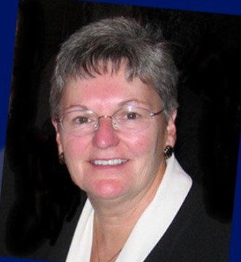Vicki is well-known and respected in the area of Women’s Collegiate Sports. Over the past 50 years, she has been a trailblazer, participant, organizer, coach, official, advocate, and observer/evaluator of officials. Vicki has been inducted into the St. Peter High School Hall of Fame, Minnesota State High School Basketball Hall of Fame, the Minnesota State High School League Hall of Fame, and the Minnesota State University Hall of Fame.

Currently, Vicki is currently the Video Coordinator and Assistant Educational Coordinator for the “Collegiate Officiating Consortium for Women’s Basketball” (COC-WBB). The consortium oversees women’s basketball officiating for the Big Ten Conference, The Big 12 Conference, Conference USA, Missouri Valley Conference, Mid-American Conference, Horizon League, Summit League and the Great Lakes Valley Conference.

From 2014 to 2022, Vicki was the Supervisor of Women’s Basketball Officials for the Northern Sun Intercollegiate Conference (NSIC). She served as the contact person for all women's basketball officiating matters within the NSIC. NSIC Commissioner Erin Lind said, “Vicki’s contribution to women’s basketball in the NSIC has been exceptional.  A true guardian of the game, she has used her knowledge to develop and enhance officiating in our league, bringing it to the next level. “

A few of the other roles Vicki has filled are: a past president of the Minnesota State Coaches Association, one of four NCAA Regional Evaluators for Women’s Basketball Officiating, the coordinator of women's basketball officials for the Minnesota Intercollegiate Athletic Conference (MIAC), an official in all three divisions of the NCAA, an observer of basketball officials for the WNBA and Big Ten Conference, and a Division III Supervisor of Women’s Basketball Officials for the Minnesota Intercollegiate Athletic Conference (MIAC) and Upper Midwest Athletic Conference (UMAC).

In 2022, St. Cloud State’s Head Women’s Basketball coach said, “Vicki has been an outstanding ambassador and advocate for women’s basketball… She has made a lasting impression on our game and we should all be thankful for the way that she has helped to grow the game of women’s basketball.”

**Membership**

***Linda Ferris & Jody Rudh***

**New Shape the Future Event - Chili Dinner on January 27, 2025**

Membership has some exciting news! The chili dinner planned for January 27 @ 6:00 has now been designated a "Shape the Future Event." This means anyone joining AAUW Hastings on this date will receive the discounted membership rate of $67.00!

We look forward to seeing you and please BRING A FRIEND!

Should you have questions please contact [Jody Rud](mailto:tjrudy@comcast.net)h or [Linda Ferris](mailto:ralmferris@msn.com).

**Book Club**

***Ann Johnson, Cindy Toppin, & Linda Bindman***

The book club meets the second Monday of the month at the Pleasant Hill Library at 1:30pm in the Old Mill Ruins room. Please join us, all are welcome!!

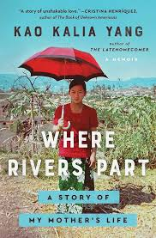For January 13th, our book selection is *Where Rivers Part: A story of My Mother’s Life* by Kao Kalia Yang (this is the Hastings Reads book). This book has been described as “a mesmerizing and hauntingly beautiful memoir about a Hmong family’s epic journey to safety told from the perspective of the author’s incredible mother who survived, and helped her family escape, against all odds.”

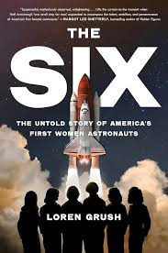 On February 10th, we will discuss *The Six: The Untold Story of America’s First Women Astronauts* by Loren Grush. This book is nonfiction and tells the story of America’s first six women astronauts. These extraordinary women each made history going to orbit aboard NASA’s Space Shuttle while enduring claustrophobic and sexist media attention. The book describes their rigorous survival training and preparing for years for the opportunity to go to space.

**2025 Hastings Reads**

Hastings celebrates the work of Kao Kalia Yang, the Star Tribune’s 2024 Artist of the Year and winner of many awards.

The theme for this year is, ***Kalia Writes, Hastings Reads***. All three books were written by Kao Kalia Yang.

*Where Rivers Part: A story of My Mother’s Life* (For teens and adults)

*The Diamond Explorer* (For middle grades)

*A Map Into the World* (For elementary grades).

The Hastings Reads Flyer and list of upcoming activities is attached at the end of the TWIG.

**Gadabouts**

***Sarah Kiani***

**Upcoming Outing:**

**Exhibit "Girlhood It's Complicated"**

<https://www.mnhs.org/historycenter/activities/museum/girlhood>

We will be going to the Minnesota History Museum on Friday 2/7 meeting in St. Phillips Lot 9:15am.

Head to History Museum 10:00-12:00 for exhibit

Optional Lunch at Cafe Latte 12:00-2:00

[https://www.cafelatte.com](https://www.cafelatte.com/)

Head back to Hastings arrival by 2:45 pm

**NOTE: this event is prepaid and pre-registered. Contact Sarah Kiani with any questions or for more details.**

[**Sarah@hopetreecounselingservices.com**](mailto:Sarah@hopetreecounselingservices.com)

**(319) 610-5711**

Also, we will be encouraging attendance and making connections at the Hastings Arts Center Coffee Concerts. These are free concerts and optional meet up at Froth and Cork afterwards for members to have a light lunch or coffee together. Supporting the wonderful work of the Hastings Arts Center and Sarah Lockwood is a great thing to do as AAUW Hastings members.

We would like to invite you to start this new tradition by attending the concert on 2/25 Tuesday with Amy Nan on Harp! Doors open 10:00 am for coffee and the concert starts at 10:30am. The Hastings Arts Center is located at 216 4th St. E. There is ample street and lot parking right across the street and the entrance is handicap accessible. Here's the link for more info:

<https://www.hastingsartscenter.org/concerts.html>

We look forward to getting out and about with you all in Gadabouts.

**Community**

***Julie Hicks***

**Black Dirt Theater**

* **Black Dirt Theater Improv**
  + Saturday January 18, 2025 at 7:00 p.m. at American Legion
  + Saturday February 8, 2025 at 7:00 p.m. at The Confluence Hotel
  + Saturday March 1, 2025 at 7:00 p.m. at Hastings Public House
  + Saturday March 22, 2025 at 7:00 p.m. at American Legion
  + Saturday April 12, 2025 at 7:00 p.m. at The Confluence Hotel
  + Saturday May 3, 2025 at 7:00 p.m. at 2nd Street Depot
  + Saturday May 24, 2025 at 7:00 p.m. at Hastings Public House
* February 14, 15, 16, 21, & 22 @ Hastings Arts Center – **Black Dirt Theater presents “Nunsense” Musical Dinner Theater Production**. Times and Tickets Available Soon! Check out [www.blackdirttheater.com](http://www.blackdirttheater.com)

**Hastings Arts Center Concerts**

216 4th Street E Hastings

* Tuesday January 14th at 10:30 a.m. – **Jonah Walt, Saxophone & Tom Jensen, Guitar** (Hastings High School graduates and now college seniors majoring in music)
* Saturday January 25th at 7:00 p.m. – **The High 48’s**
* Tuesday February 25th at 10:30 a.m. – **Amy Nam – Harp**
* Tuesday March 4th at 10:30 a.m. – **Lux String Quartet**
* Friday March 28th at 7:30 p.m. – **Metro Brass presents “Movie Magic”** with special guest Reed Grimm
* Tuesday April 8 at 10:30 a.m. – **Featuring Spencer Johnson Historian with musicians Erik Pearson and Sarah Lockwood**
* Saturday-April 12th at 7:00 p.m. – **Brass Lassie** – a bold trad band based in the Twin Cities of St. Paul/Minneapolis, combines traditional tunes, songs and style with dazzling modern horn lines, sparking their own genre of eclectic, remarkable music
* Tuesday May 6th at 10:30 a.m. – **Artu Duo – Ruth Marshal – cello and Garret Ross - piano**
* Saturday-May 17th at 7:00 p.m. – **Jenny Klukken**, **marimbist and her Jazz Combo**. Classically-trained, jazz and world music crossover artist, genre-blending performer and composer. A great concert to close our 10th concert season!

**Hastings Concert Association Concerts**

Held at Hastings Middle School Auditorium – 1000 11th St. W.

* Saturday February 22, 2025 at 7:00 p.m. **“Letters from Home”** – USO Style Show with high energy singing and tap dancing
* Monday March 24, 2025at 7:00 p.m. – **Jeremy Stolle** – No More Talk of Darkness
* Sunday April 27, 2025 at 3:00 p.m. – **“Rock It Man” Dueling Piano Show**

Individual Concerts are $25

Allied Concert Services, Inc. [http://www.alliedconcertservices.com](http://www.alliedconcertservices.com/) ; [+1 (763) 559-8019](tel:+17635598019)

**Hastings Downtown Business Association**

* Saturday January 18th 2025 – **Hastings Ice Sculpture Celebration** from 11`:00 a.m. – 4:00 p.m.
* Saturday February 15, 2025 **Frozen Mulligan** from 12:00 p.m. – 4:00 p.m. Nine-hole mini golf course around Downtown Hastings, MN. ⛳️❄️

**Web Page**

***Linda Ferris***

Accidently delete your email with the latest directory?

Forget where our meeting is located this month?

Then, check the website!

Here’s the link: <https://hastings-mn.aauw.net/>

**Diversity**

***Lisa Hedin***

Happy New Year! Welcome to 2025. January includes recognition and celebrations of Braille, Martin Luther King Junior and Holocaust Remembrance.

World Braille Day (January 4), celebrated since 2019, is observed to raise awareness of the importance of Braille as a means of communication in the full realization of the human rights for blind and partially sighted people. Even under normal circumstances, persons with disabilities—one billion people worldwide— are less likely to access health care, education, employment and to participate in the community. They are more likely to live in poverty, experience higher rates of violence, neglect and abuse, and are among the most marginalized in any crisis-affected community. Braille (named after its inventor in 19th century France, Louis Braille) is used by blind and partially sighted people to read the same books and periodicals as those printed in a visual font.

Braille is essential in the context of education, freedom of expression and opinion, as well as social inclusion, as reflected in article 2 of the [Convention on the Rights of Persons with Disabilities](https://social.desa.un.org/issues/disability/crpd/convention-on-the-rights-of-persons-with-disabilities-crpd).

Dr. Martin Luther King Jr. was a tireless advocate for racial equality, working classes, and the oppressed around the world. Commonly called Martin Luther King, Jr. Day or MLK Day, the third Monday of January is a federal holiday to honor his life and legacy. This is the only federal holiday designated as a National Day of Service to encourage all Americans to volunteer to improve their communities. While Dr. King believed this community was possible, he acknowledged and fought for systemic change. His example is our call to action. How will you participate?

The United Nations General Assembly designated January 27—the anniversary of the liberation of [Auschwitz-Birkenau](https://encyclopedia.ushmm.org/content/en/article/auschwitz)—as [International Holocaust Remembrance Day](https://encyclopedia.ushmm.org/content/en/article/international-holocaust-remembrance-day), a time to remember the six million Jewish victims of the Holocaust and the millions of other victims of Nazi persecution.

All of us can mark International Holocaust Remembrance Day by sharing the truth of the Holocaust and by confronting antisemitism and hate in our daily lives. Learn more about the 2025 Commemoration activities taking place at the United States Holocaust Memorial Museum here https://www.ushmm.org/remember/international-holocaust-remembrance-day.

Sources: National Park Service website, United States Holocaust Memorial Museum website, United Nations Website

**Our annual AAUW Holiday Event was a great success at the Hastings Golf Club.**

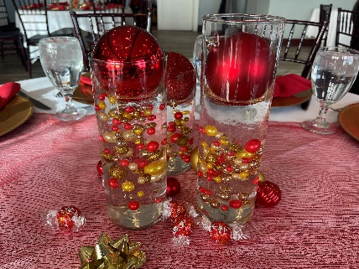We celebrated some holiday cheer on Saturday, December 7th. Famous decor of red and gold was displayed on the tables with napkins tied perfectly in red bows.

The morning started out with a welcome message, delicious breakfast buffet, a pass the bow game and entertainment by local HHS graduate Ellie Storkamp.

The committee surprised us with raffle tickets to "An Andy and Bing Christmas” presented by Mick Sterling at the Sheldon Theater, poinsettia plants, and take-home wine charms to use for future holiday events.

Our 3rd generation members also attended the holiday event - Judy Peacha, Jody and Mya Rudh and Kathy Stockman, Julie and Taylor Larson. There are pictures at the end of the TWIG.

Happy New Year to all!!!

**E.R.A. History**

***Dorothy Sandahl***

The **Equal Rights Amendment** (**ERA**) is a [proposed amendment](https://en.wikipedia.org/wiki/Article_Five_of_the_United_States_Constitution#Proposing_amendments)  was first introduced in 1923, but it took until 1972 before it passed in the Congress with the purpose of the ERA to guarantee equal legal rights for all American citizens regardless of sex; explicitly prohibit sex discrimination. Next up was to garner the support of two-thirds of the states. A deadline was set for ratification within seven years, and when that failed, it was extended to 1982; it failed again. Why do we need this?

* Women’s wage gap is approximately 86% of men’s salaries.
* Congress can vote along party lines to roll back protections granted by the Violence Against Women Act (VAWA). In the 2000 [U.S. Supreme Court](https://en.wikipedia.org/wiki/U.S._Supreme_Court) case a sharply divided court struck down the VAWA provision allowing women the right to sue the accused in federal court.
* Women are vulnerable at the workplace. If she becomes pregnant, the employer has rights to discriminate. A Supreme Court Justice believes the Constitution does *not* prohibit sex discrimination.
* Reproductive rights are argued about at every election with over 60% of the country agreeing on what basic rights should be. But Women can have all rights taken away under the **Comstock Act of 1873** (a series of current provisions in Federal law that generally criminalize the involvement of the [United States Postal Service](https://en.wikipedia.org/wiki/United_States_Postal_Service), its officers, or a [common carrier](https://en.wikipedia.org/wiki/Common_carrier) in conveying [obscene matter](https://en.wikipedia.org/wiki/United_States_obscenity_law),[[1]](https://en.wikipedia.org/wiki/Comstock_Act_of_1873#cite_note-1) crime-inciting matter, or certain [abortion](https://en.wikipedia.org/wiki/Abortion)-related matter).

In the early history of the Equal Rights Amendment, arguments against varied from middle-class women who were largely supportive, while those speaking for the working class were often opposed. They argued that women should hold more domestic responsibility and that employed women needed special protections regarding working conditions and employment hours.

Modern proponents assert it would end legal distinctions between men and women in matters of divorce, property ,  [employment](https://en.wikipedia.org/wiki/Employment_discrimination), and other matters.

Opponents have argued that it would remove protections from women and open women to be [drafted](https://en.wikipedia.org/wiki/Conscription_in_the_United_States) into the military. Many amendments have been recommended which often caused failure of ratification.

AAUW was involved in the beginning and continues to draw support by all the members to move ERA forward for ratification. Recent polling from [Data for Progress finds](https://www.dataforprogress.org/blog/2022/6/2/fifty-years-later-voters-support-passing-the-equal-rights-amendment) that 85 percent of likely voters support Congress passing the ERA to give it a second chance at being adopted as a constitutional amendment, supported by both Democrats and Republicans.

In order to have an amendment adopted, two-thirds of states, or 38 states, must ratify the measure. That threshold was passed in 2020, when Virginia became the 38th state to do so. But the Trump administration blocked the ERA’s adoption, [saying that](https://truthout.org/articles/dark-money-womens-groups-are-using-anti-trans-scaremongering-to-oppose-era/) the seven-year deadline that was set in 1972 to have states ratify the measure had passed. Biden lawyers have been arguing in court that this is not true. Many feel Biden should act on it and just post the publication of the amendment.

More work to be done.

We are gathering in Minnesota, one of the states that has not ratified the amendment to ask our legislature to post this publication for a vote to ratify. ***Feb 14th, 10:00am, State Capital, let’s do it!!***

**In Sympathy**

Sympathy and prayers for Beverly McCumber, Charter Member of Hastings Branch AAUW, whose husband Rod passed away recently.

For those wishing to send cards, please mail to

Beverly McCumber

1690 Creek Ridge Trail

Minnetonka, MN 55345.

**Historian**

***Lisa Hedin***

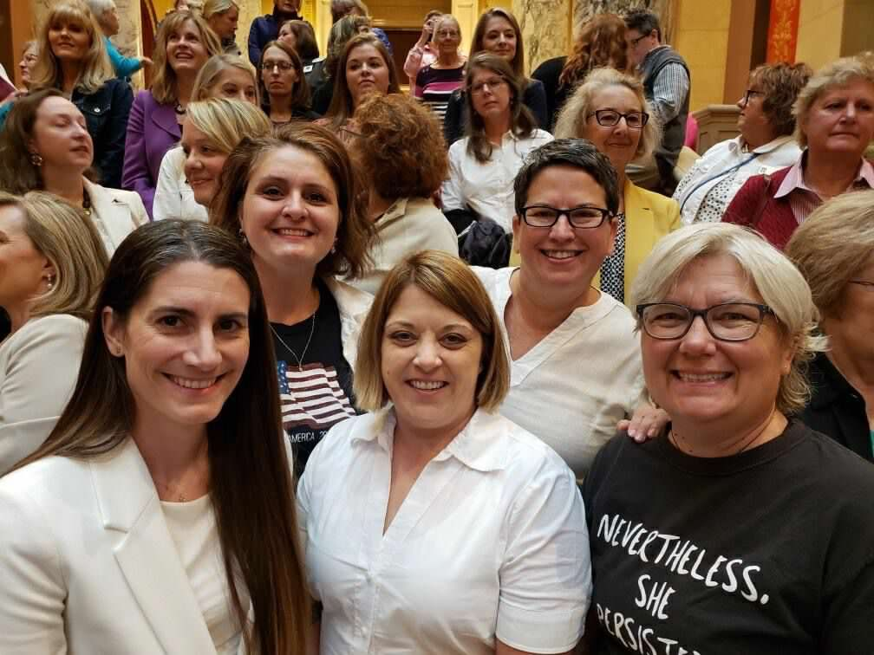

And, we continue to work to get the ERA passed

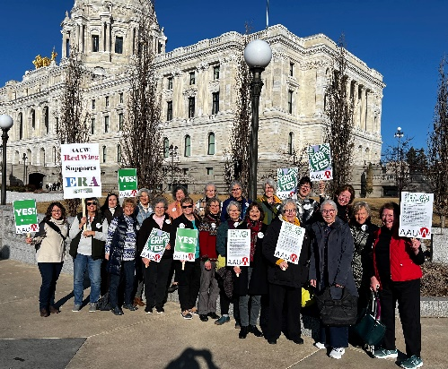

**AAUW Mission Statement**

To advance gender equity for women and girls through research, education, and advocacy.

**AAUW Vision Statement**

Equity for all.

**Minnesota State Website**

[**http://aauw-mn.aauw.net**](http://aauw-mn.aauw.net)

**National Website**

[**https://www.aauw.org/**](https://www.aauw.org/)

**Hospitality**

For those of you who attended November’s meeting/program and were lucky to try one (or two) of Patty Wilson’s Lemon Ricotta Cookies, you will understand why the recipe can be found at the end of the TWIG!!

**Secretary**

***Becky Arenivar***

AAUW Hastings Branch - General Membership Business Meeting Minutes

November 25, 2024, 7:00 p.m. Location: St. Philip's Lutheran Church and Zoom

Attendance: 40-45

1. Meeting called to order at 7:02 p.m. by D. Sandahl.
2. Opening activity: D. Sandahl presented a DEI activity designed to help members recognize biases we have had and how we have overcome them.
3. October 2024 Meeting Minutes: P. Powers moved to approve; P. Wilson seconded. Minutes approved unanimously.
4. Treasurer's Report: R. Souza  
   Checking account balance at beginning of month = $23,450; expenses paid during month = $8,900; current checking account balance = $14,550. Our annual projected budget has been updated to include the HHS scholarship amounts approved at November’s Board meeting. Net income from the Wine Soirée totaled just under $8,000. November expenses included speaker fees and the Zoom conference fee.
5. Committee Reports:
   1. Fundraising: - C. Strauss  
      We are participating in Hastings Family Service’s Adopt-a-Family program. Members can sign up to buy one or more requested items, then bring unwrapped items to the Holiday Party on Dec. 7. Two ways to sign up: 1) Sign-up Genius – members will receive an email; and, 2) A sign-up form being passed around at tonight’s meeting. L. Bindman explained how to use Sign-Up Genius.
   2. Membership: J. Rudh  
      Holiday Party is December 7 at 10:00 a.m. Please disregard start time of 10:30 a.m. on the bookmark. One new member and one guest are at tonight’s meeting.
   3. Programs: D. Elling-Schultz  
      A notice was placed in the Hastings Journal promoting tonight’s presentation.  
      The January 27, 2025 meeting will start at 6:00 p.m. and include our annual Chili Supper. Vicki Davis, former counselor at Hastings High School, will present on *How Has Title IX Changed Collegiate Sports and Games*.
   4. NCCWSL: G. Glashan   
      AAUW National announced that starting in 2025-2026, management of NCCWSL will be shared with NASPA (Student Affairs Administrators in Higher Education).
   5. Book Club: C. Toppin  
      The book club will discuss *The Secret Book of Flora Lea*, a WWII story about two sisters evacuated from London, on Mon., Dec. 9 at 1:30 p.m at Pleasant Hill Library.
   6. Gadabouts – Ten members are going to see *Black Nativity* on December 14. The next Gadabouts event will be a trip to the Minnesota History Center on February 7 to see *Girlhood (It’s complicated),* a traveling exhibit from the Smithsonian.
   7. Scholarships – M. Tennessen  
      AAUW Hastings Board approved $8,000 is scholarships for the 2024-2025 school year: 2 x $2500 scholarships to students demonstrating high academic achievement, and 2 x $1500 scholarships to students pursuing education in non-traditional fields.  
      The committee will receive student applications in January and will need volunteers to help read, discuss and choose scholarship awardees. They use a rubrik to evaluate applications and must complete evaluations within of receivia weekng applications.
   8. Community – J. Hicks   
      Annual Gobble Gait fundraiser for Hastings Family Service is on Nov. 28 (Thanksgiving). Holiday Hoopla in downtown Hastings is on Saturday, November 30 as part of Small Business Saturday. River Valley Chorale, a new community choral group, will perform their Winter Concert on Sun., December 15 at 2:00 p.m. at the Hastings High School auditorium.
   9. Diversity Committee: a committee has been formed and is looking at ways to incorporate AAUW DEI values and goals into our branch’s activities and operations.

Adjournment: D. Elling-Schultz moved to adjourn; M. Tjomsland seconded. The meeting was adjourned at 7:33 p.m.

**AAUW Hastings Board**

President ---------------- Dorothy Sandahl

VPs Membership ------ Linda Ferris

Jody Rudh

VPs Programs ---------- Danna Elling Schultz

Mary Ellen Fox

Becky Gartzke

Secretary --------------- Becky Arenivar

Treasurers --------------- Renee Souza

Carol Tobin

AAUW Funds --------- Marilyn Tennessen

Book Club -------------- Ann Johnson

Cindy Toppin

Linda Bindman

Community ------------ Julie Hicks

Diversity ---------------- Members

Gadabouts --------------- Sarah Kiani

Historian ---------------- Lisa Hedin

Hospitality -------------- Nancy Ahn

Darla Kimmes

Lois Twedt

NCCWSL --------------- Gail Glashan

Newsletter -------------- Linda Bindman

Public Policy ----------- Pat Powers

Fundraising ------------- Ceil Strauss

Julie Larson

Web Page --------------- Linda Ferris



