**UPCOMING EVENTS**

**March 10. …….……………...……. Book Club**

**March 24 ...……………...Meeting & Program**

**April 1……………NCCWSL applications due**

**April 14 …………………..………. Book Club**

**HASTINGS BRANCH**

**Meets on Mondays**

**St. Philip’s Lutheran Church**

**1401 15th Street West,**

**Hastings, Minnesota 55033**

**2023-2024 PROGRAMS**

**September 23, 6:00 pm Salad Supper**

**Braver Angels**

**JoAnn Ward**

**October 28, 7:00 pm**

**Therapy Dogs: Biophilia and the Importance of Animal Kinship**

**Tanya Bailey & Maureen Kleckner**

**November 25, 7:00 pm**

**Women’s Work: Minnesota women’s contribution to the paid and unpaid economy**

**Christina Ewig, Univ of Minnesota Center for Women and Gender Public Policy**

**December 7, 10:00 am**

**Holiday Celebration at the Public House**

**January 27, 6:00 pm Chili Supper**

**Title IX: How has Title IX changed collegiate sports and games**

**Vicki Davis**

**February 24, 7:00 pm**

**Astronomy is for Everyone**

**Alex Grenbaum**

**March 24, 7:00 pm**

**The State of Dakota County**

**Dakota County Attorney Kathryn Keena**

**April 28, 6:00 pm Spring Social**

**Identity Culture and You**

**Kim Allgor**

**May 19, 7:00 pm Book Sale**

**Immigrant Integration System**

**Pat Branstad, Uniting Cultures/Uniendo Culturas**

**President’s Message**

***Dorothy Sandahl***

Why are you a member of AAUW? Education Programs, Comradery, Support for Women/Scholarships or is it the great Book club? Whatever it is, **Share** it with all the women you meet and **invite** them to join our fellowship to add to the fun! Send them an email or invitation card or find some creative avenue. Be clear, we are welcoming and have something to offer all women in support, direction and training, and engaging issues.

Why do I support AAUW in Hastings…because there are so many intelligent, energetic, interesting, and joyous personalities with this group of women. Fun to be around and continue to learn from each of you. With that said, as President you are making sure I keep us organized, future focused and making progress in all our goals. But I can’t do that without your help.

You may be receiving a call shortly from our Nominating Team, asking you to volunteer for an open position of Treasurer, Program leadership or Community Information. We have job descriptions ready and just need a person to hand them to. It might be the best thing you ever did! Or even better, call us before we call you if you are interested in any of these roles.

AAUW Hastings Branch is on a rollllll! Let’s keep the membership increasing, the ideas and actions poppin’, and a fellowship filled with Joy!

**AAUW Greatest Needs Fund**

National ‘The Greatest Needs Fund’ is a vital source of unrestricted support that allows AAUW to respond quickly and effectively to emerging challenges and opportunities in Washington. **Your donation today will help us:**.

* Defend and strengthen Title IX protections to safeguard equal educational opportunities for women and ensure that all students receive the education they deserve.
* Support college affordability programs that provide financial aid and loan repayment options to make higher education accessible for all students.
* Fight back against legislative threats that seek to defund crucial education programs.

Your contributions to this fund are crucial for AAUW’s agility and long-term sustainability, empowering the organization to drive and sustain meaningful issues that arise.

Each Branch is urged to **Raise $30 per member** in FY2025 towards the Greatest Needs Fund. We are so close with~$2000, so we only need another $1000 to meet our goal. Check out the National Platform and support these efforts moving forward.

**Program**

***Danna Elling Schultz, Mary Ellen Fox & Becky Gartzke***

**The State of Dakota County**

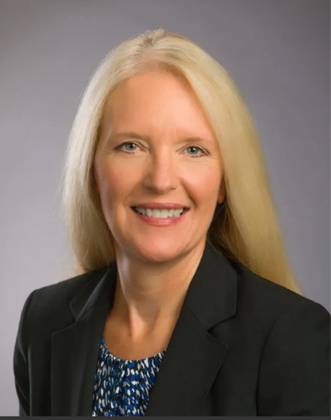Kathy Keena was appointed as the Dakota County Attorney by the Board of Commissioners May 2021 and elected November 2022. She is the 24th Dakota County Attorney and the first woman to serve in this position. Kathy has been at the Dakota County Attorney’s Office for 25 years, serving in multiple roles including criminal division head and chief deputy. Prior to Dakota County, she was the county attorney in Lyon County and worked in private practice. Ms. Keena graduated from Minnesota State University Moorhead with a bachelor’s degree in criminal justice and sociology and received her J.D. from Hamline University School of Law, now Mitchell Hamline School of Law.

**Volunteer Opportunity**

***Lisa Hedin***

Future Workforce Initiative is a partnership between the Hastings Chamber of Commerce and Hastings High School to help strengthen student’s workforce skills. AAUW Hastings has an opportunity to help on April 24 from 9:15-11:00 am at Hastings High School by conducting Mock Interviews. This is the first time this event has been held at the high school, and we are estimating 10 people will be needed. Questions and general guidance will be provided to volunteers. If interested reach out to Lisa Hedin at [lmhedin@yahoo.com](mailto:lmhedin@yahoo.com), and you will be added to the list!

**Book Club**

***Ann Johnson, Cindy Toppin, & Linda Bindman***

The book club meets the second Monday of the month at the Pleasant Hill Library at 1:30pm in the Old Mill Ruins room. Please join us, all are welcome!!

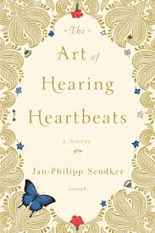On March 10th, our selection is *The Art of Hearing Heartbeats* by Jan-Philipp Sendker. This novel is about a successful NY lawyer who suddenly disappears without a trace. His family finds a love letter he wrote many years ago to a Burmese woman they have never heard of. Intent on solving the mystery and coming to terms with her father’s past, Julia decides to travel to the village where the woman lived. There she uncovers a tale of unimaginable hardship, resilience, and passion that will reaffirm the reader’s belief in the power of love to move mountains.

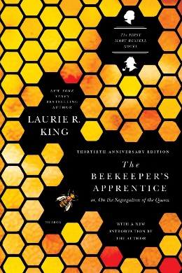

On April 14th, we will be discussing *The Beekeeper’s Apprentice* by Laurie R. King. This enjoyable mystery includes a long retired middle-aged Sherlock Holmes and a young, brilliant Mary Russell whose intellect matches his. Mary becomes Sherlock’s apprentice.

The May selection is *The Mostly True Story of Tanner & Louise* by Colleen Oakley.

**AAUW Mission Statement**

To advance gender equity for women and girls through research, education, and advocacy.

**AAUW Vision Statement**

Equity for all.

**Minnesota State Website**

[**http://aauw-mn.aauw.net**](http://aauw-mn.aauw.net)

**National Website**

[**https://www.aauw.org/**](https://www.aauw.org/)

**NCCWSL 2025**

***Gail Glashan***

**AAUW Hastings Branch will award Scholarships to**

**NCCWSL 2025**

**What is NCCWSL? Who should apply?**

AAUW invites hundreds of college women from around the country for leadership training, inspiration and networking at the National Conference for College Women Student Leaders (NCCWSL).

May 28—May 30, 2025

University of Maryland, College Park (DC metro area)

Once again, our AAUW Hastings Branch is pleased to offer a scholarship to NCCWSL 2025! Since 2015, our branch has sent 19 college women to NCCWSL including five college women to virtual NCCWSL. NCCWSL is an empowering space to build leadership skills and to connect with peers. Through engaging workshops and hands-on activities, NCCWSL challenges and inspires attendees to make meaningful impact on their campuses and communities long after the conference ends.

Branch members are encouraged to help spread the word that the application process for 2025 is now open!

**Completed applications are due April 1**. If you happen to know a sophomore or junior college woman student, please encourage her to apply. Just forward the attached NCCWSL flyer and application at the end of this Twig.

Information and the NCCWSL 2025 application can be found on our AAUW Hastings Branch webpage—under Activities: <https://hastings-mn.aauw.net>

Or email Gail at... [AAUWHastingsBranch@gmail.com](mailto:AAUWHastingsBranch@gmail.com)

AAUW Empowering Women and Girls in Hastings since 1970!

After all applications are in, the AAUW Hastings NCCWSL Committee will look at the applications with the following criteria in mind and in this order:

1. Hastings High School graduate

2. DCTC enrolled student

3. Hastings connection

Sophomore or junior year applicants are preferred; however, freshman and seniors are not excluded.

Leadership skills, or, an interest in building leadership skills, will be strongly considered.

**Communications Team**

***Linda Bindman & Julie Hicks***

Introducing the Hastings AAUW Communications Team – Linda Bindman – Internal (Twig), Julie Hicks – External, along with Danna Elling-Schultz and Patty Wilson.

We are charged with communicating our Hastings AAUW mission, vision and events to our members and to the Hastings Community to grow our visibility and membership. We will be doing this through the local radio station, TV station, newspaper and Chamber of Commerce in addition to our website and Facebook page. If you have any ideas or connections or ideas, please let us know. Thanks

**Treasurer’s Report**

***Renee Souza***

February brought an incredible outpouring of memorial contributions in honor of Ann Skoglund, totaling a generous $700 for scholarship distribution. We will be reaching out to express our gratitude and share what a meaningful tribute this has been for Hastings AAUW.

At the start of the month, our checking account held a strong balance of $12,700. Thanks to the diligent efforts of our membership team in aligning dues and payments with state and national requirements, we now have greater financial clarity for the upcoming budgeting year.

After covering expenses, we closed the month with a solid $12,500 and are excited to continue our membership drive in the months ahead!

**Hospitality**

***Nancy Ahn, Darla Kimmes, & Lois Twedt***

**AAUW Spring Social, 2025**

Get ready for a springalicious night out!

The AAUW Spring Social is on **Monday, April 28**, at The Hastings Public House,

2015 Westview Drive, Hastings, MN 55033.

**Check in: 5:30PM Dinner: 6:00PM**

**After the business meeting, Kim Allgor, mother of AAUW member Rachel Allgor, will present a program entitled**

***Identity, Culture and You***

**Cost: $35 Checks payable to THE HASTINGS PUBLIC HOUSE** or **Cash** (payment envelopes will be provided at the March meeting)

Checks may also be sent to Nancy Ahn, 1600 Westview Drive, Hastings, MN.

Payment using **Venmo** will be a third option. Thank you, Xillian Maceda.

**The deadline for payment is April 15.**

Please come and enjoy an evening with fellow members.

“Friends. Sisters. Mothers. Professors.

When women affirm women, it unlocks our power.

It gives us permission to shine brighter.”

**Technology, Web Page & Facebook**

***Linda Ferris, Rachel Allgor, Susan Just, & Amelia Strauss***

As noted at the February meeting, we have now created a new AAUW Hastings Facebook page. The page is public and we'd love it if our members followed us as well as shared the page with others in the Hastings community. To follow us on FB, log into your FB account, enter **AAUW Hastings** into the search box and when the page appears click **Follow**.

Additionally, we are in need of a Facebook expert to keep us out of FB jail. If you have expertise in this area, please reach out to Linda at [ralimferris@msn.com](mailto:ralimferris@msn.com).

**AAUW MINNESOTA STATE MEETING**

**April 25-26, 2025**

Austin Country Club/Hormel Institute, Austin, MN

“Cultivating Hope Through History”

Greetings from Spamtown USA!

The Austin Branch of AAUW is looking forward to welcoming you to our town on April

25th and 26th for the AAUW Minnesota State Meeting. We have a busy two days planned for

you. The main hotel is the Double Tree by Hilton. We will have members in the lobby starting at

noon to provide information. Registration packets will be available at the Austin Country Club

beginning at 4:30 and again on Saturday morning at the Hormel Institute.

More information about the Minnesota State Meeting along with the registration form can be found on the AAUW MN website. (There is also a registration form at the back of the TWIG)

<https://aauw-mn.aauw.net/>

**Silent Auction Basket for State Meeting *Pat Powers***

Hastings Branch is donating a basket (or more than one) to the Silent Auction at the State Meeting in Austin. We are soliciting items from the women in business that we know. We would accept items from all of you. We can make more than one basket if a second theme emerges or items may stand alone. Gift cards make a good item. Tickets to events make a good item, too. Bring your item to the March meeting. We need to report to the Austin Silent Auction coordinator by the end of March.

**Community**

***Julie Hicks***

**Black Dirt Theater**

* **Black Dirt Theater Improv**
  + Saturday March 22, 2025 at 7:00 p.m. at American Legion
  + Saturday April 12, 2025 at 7:00 p.m. at The Confluence Hotel
  + Saturday May 3, 2025 at 7:00 p.m. at 2nd Street Depot
  + Saturday May 24, 2025 at 7:00 p.m. at Hastings Public House
  + Spring 2025 – Tom Stoppard’s Rosencrantz & Guildenstern are Dead – [www.blackdirttheater.com](http://www.blackdirttheater.com)

**Dakota County Historical Society – Le Duc Historic Estate**

* **Mother’s Day Tea –** Saturday May 10, 2025 and Sunday May 11, 2025 at 2:00 p.m. <https://www.dakotahistory.org/events/1032-may-10-11-mother-s-day-tea-a>

**City of Hastings**

* **Levee Park Events** – Details to follow
* **Maker’s Market –** The City of Hastings' 2025 Music + Market is a place for area makers to sell their goods during live music performances adjacent to our historic downtown and riverfront park. We welcome artists, makers, crafters and small brands. Thursdays 6-8:30 p.m.
  + June 5, 12, 26; July 3, 10, 24, 31; Aug 7, 21, 28 and Sep 2, 11
* **Make Music Day –** Saturday June 21, 2025 – more details to follow

**Hastings Arts Center Concerts**

216 4th Street East Hastings – [www.hastingsartcenter.org](http://www.hastingsartcenter.org) 651-437-4320

* Saturday March 22nd at 2:00 p.m. – **Bells of the Bluffs “Musical Magic”**
* Friday March 28th at 7:30 p.m. – **Metro Brass presents “Movie Magic”** with special guest Reed Grimm
* Tuesday April 8 at 10:30 a.m. – **Featuring Spencer Johnson Historian with musicians Erik Pearson and Sarah Lockwood – celebrating the 10th Anniversary of the Hastings Arts Center and 160th Anniversary of the church building.**
* Saturday-April 12th at 7:00 p.m. – **Brass Lassie** – a bold trad band based in the Twin Cities of St. Paul/Minneapolis, combines traditional tunes, songs and style with dazzling modern horn lines, sparking their own genre of eclectic, remarkable music
* Tuesday May 6th at 10:30 a.m. – **Artu Duo – Ruth Marshal – cello and Garret Ross - piano**
* Saturday-May 17th at 7:00 p.m. – **Jenny Klukken**, **marimbist and her Jazz Combo**. Classically-trained, jazz and world music crossover artist, genre-blending performer and composer. A great concert to close our 10th concert season!

**Hastings Concert Association Concerts**

Held at Hastings Middle School Auditorium – 1000 11th St. W.

* Monday March 24, 2025at 7:00 p.m. – **Jeremy Stolle** – No More Talk of Darkness
* Sunday April 27, 2025 at 4:00 p.m. – **“Rock It Man” Dueling Piano Show**

Individual Concerts are $25

Allied Concert Services, Inc. [http://www.alliedconcertservices.com](http://www.alliedconcertservices.com/) ; [1-763-559-8019](tel:+17635598019)

**Hastings Downtown Business Association**

* **Hastings Historic Car Shows 2025** in Downtown Hastings 11:00 am – 4:00 p.m. The show is limited to classic cars & trucks from 1985 and older. (No motorcycles at this time)
  + Sunday May 18th 2025
  + Sunday June 15th 2025
  + Sunday July 20th 2025- *Rivertown Days*
  + Sunday August 17th 2025
  + Sunday September 21st 2025
  + Sunday October 12th 2025- *2nd Sunday of the month*

**Hastings Rivertown Days –** July 17-20, 2025 – Our **“AAUW Book Sale”** will be held at the Arts & Crafts Fair Saturday July 19 and Sunday July 20 – more details to follow.

**Diversity**

***Lisa Hedin***

In the United States, **March is Women’s History Month** providing a time for the individual and collective acknowledgement of women’s contributions, past and present. But before there was a month there was a day and then a week.

The first National Woman's Day was observed in the United States on 28 February 1909. The Socialist Party of America designated this day in honor of the 1908 garment workers' strike in New York, where women protested against working conditions. Officially recognized by the United Nations in 1977, International Women's Day (March 8) first emerged from the activities of labor movements at the turn of the twentieth century in North America and across Europe. The 2025 International Women’s Day theme is “For ALL women and girls: Rights. Equality. Empowerment.”

A Women’ s History Week was celebrated by the Education Task Force of the Sonoma County Commission on the Status of Women in 1978. Then in 1980, President Carter issued the first Presidential Proclamation declaring March 2-8 as National Women’s History Week. In 1987 in response to continued efforts by national organizations, Congress established March as Women’s History Month and an annual federally recognized observance. Since 1995 it has been designated by presidential proclamation as a time to honor, acknowledge, and study women’s accomplishments throughout American history. Check out the Smithsonian American Women’s History Museum website for much more information, https://womenshistory.si.edu/womens-history-month

Sources: Smithsonian American Women’s History Museum website, United Nations website.

**Local Hastings School District News**

***Lisa Hedin***

**Policy:** At the March 26, 2025 school board meeting, the Hastings School District will vote on the elimination of Policy 100 Equity and Diversity link here: <https://core-docs.s3.us-east-1.amazonaws.com/documents/asset/uploaded_file/4642/HPS/4176707/100_Hastings_Equity_and_Diversity_-_Google_Docs.pdf> . Then meetings is scheduled to begin at 6:00 pm at Hastings Middle School media center. It will likely also be broadcast on HCTV’s YouTube page, The policy could be maintained, revised, eliminated or the question could be tabled. Take time to consider your position on this action and share your perspective with school board representatives. AAUW has a strong guiding principle of equity in education.

**Public Meetings:** The Hastings School Board will be hosting Community Collaboration events on Thursday, March 27 and April 17 at Hastings High School in the Lecture Hall (just past the gyms on the upper level). All Board members will be in attendance. The March meeting will be focused on gathering input on a revision of the District’s Strategic Plan. The April meeting will be focused on gathering feedback on budget cuts anticipated for the 20250-26 school year. Do public meetings count as Gad-Abouts? Could be so, we could go out for a snack afterwards!

**School Board Seat Appointment:** The process has been identified to fill the school board seat left empty upon the death of Director Jennifer Wiederholt Pine. Letters of interest are due to the District Office (Attn: Lyndee Humble [lhumble@isd200.org](mailto:lhumble@isd200.org)) by noon on Friday, 21 March. If interviews are required, they will be held between March 27 and April 8. Appointee selection will be completed on 9 April, and the selected candidate will be seated on 23 April. This appointment will be 23 April-31 December 2025. A special election will be held in November 2025 with the winning candidate serving the remainer or Director Pine’s term (1 January 2026 – 31 December 2028).

**Historian**

***Lisa Hedin***

Music sooths the AAUW Hastings soul:

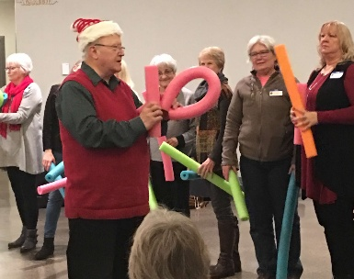

Holiday Party 2019

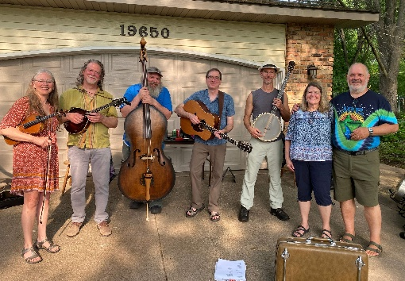

Raffle Winner Concert 2023

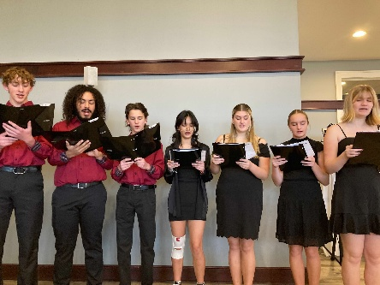

Holiday Party 2023

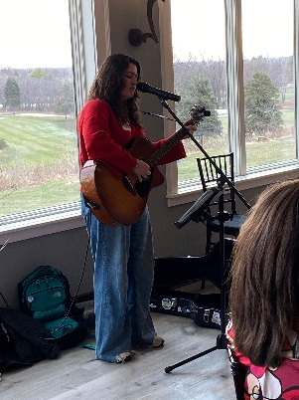

Holiday Party 2024

**Secretary**

***Becky Arenivar***

AAUW Hastings Branch ‐ General Membership Business Meeting Minutes

February 24, 2025, 7:00 p.m. Location: St. Philip's Lutheran Church and Zoom

Attendance: 40-45

1. Meeting called to order at 7:03 p.m. by D. Sandahl.
2. President’s Message:   
   AAUW Minnesota 2025 state convention is April 26-27 in Austin, MN; we can send 6 delegates. Contact D. Sandahl to sign up to be a delegate.  
   Hastings branch has several projects in hand for 2025, including our 2025-26 budget, bylaws and strategic plan. Contact D. Sandahl if you have ideas to contribute to these projects.
3. January 27, 2025 Meeting Minutes: L. Hedin moved to approve; K. O’Keefe seconded. Minutes approved unanimously by voice vote.
4. Treasurer's Report: R. Souza  
   Checking balance as of Jan. 1 = $13,000; as of Jan. 31 = $12,500. Work on the 2025-2026 budget will begin soon. Prudent Reserves will be discussed when 2025-26 budget is brought forward for approval.
5. Committee Reports:
   1. Communications – P. Powers  
      You can help AAUW Hastings increase our visibility in the community by joining the new Communications Committee. This committee will identify and engage with local outlets and organizations to bring awareness of our activities to a wider audience. Contact Pat Powers if you want to join this important new effort. Possible ideas include posts on HastingsNow.com, articles and notices in the Hastings Journal, joining the Hastings Chamber of Commerce, and more.
   2. Public Policy – P. Powers  
      AAUW 2-Minute Activist tools make it easy for you to make sure state and national legislators know what’s important to you and where you stand on issues that impact women – [www.aauw.org/act/two-minute-activist/](http://www.aauw.org/act/two-minute-activist/).
   3. Technology Team – L. Ferris  
      Our Facebook page was put in jail. Linda is working to get our page re-activated or to rebuild it. AAUW Hastings website has new content, including information about NCCWSL.
   4. Membership – J. Rudh  
      We currently have 118 members. New members who join at a monthly meeting get the discounted $67 membership fee, so bring a friend to a meeting.
   5. NCCWSL – G. Glashan  
      NCCWSL 2025 conference is May 28-30 at the University of Maryland, College Park. Applications for this year’s scholarships are available now.
   6. Book Club – A. Johnson   
      Book club will discuss *The Art Of Hearing Heartbeats* by Jan-Philipp Sendker on March 10 at 1:30 p.m. at the Pleasant Hill Library.
   7. Scholarship – M. Tennessen  
      Thank you to the members who helped read and evaluate the 16 applications we received. The names of our four scholarship winners will be announced in May.
   8. Community – J. Hicks  
      Send information about community events to Julie Hicks for posting in the TWIG.
   9. DEI – L. Hedin  
      The Hastings School Board is considering sun-setting the school system’s DEI Policy (Policy 100). This item is at the agenda for the Wednesday, Feb. 26 School Board meeting at 6:00 p.m. at the Hastings Middle School Media Center. Openings for public input at the meeting are full, but you can show your support for continuing the DEI policy by attending the meeting or emailing school board members.
   10. Gadabouts: S. Kiani  
       March outing is to the Irish Day of Dance on March 17 at the Landmark Center in St. Paul. Tickets are $7 at the door. This event features performances by top-level dance groups from Irish dance schools around the metro area. Contact Sarah Kiani for details and transportation information.  
       April outing will be to the Minneapolis Institute of Arts for Art In Bloom which runs from April 24-27.
   11. Programs  
       Upcoming meetings include our Spring Social in April and the members’ book sale in May. Time and location for the April meeting are TBD.
6. Adjournment: G. Schnirring moved to adjourn; B. Tennessen seconded. The meeting was adjourned at 7:39 p.m.

**AAUW Hastings Board**

President --------------------------- Dorothy Sandahl

VPs Membership ----------------- Linda Ferris

Jody Rudh

VPs Programs -------------------- Danna Elling Schultz

Mary Ellen Fox

Becky Gartzke

Secretary --------------------------- Becky Arenivar

Treasurer/Finance --------------- Renee Souza

Book Club & Hastings Reads ----Linda Bindman

Communication -------------------- Linda Bindman

Julie Hicks

Community ------------------------- Julie Hicks

Diversity ---------------------------- Jody Husting

Fundraising ----------------------- Ceil Strauss

Julie Larson

Funds & HS Scholarships ------- Marilyn Tennessen

Gadabouts --------------------------- Sarah Kiani

Historian/School Liaison -----------Lisa Hedin

Hospitality ------------------ Nancy Ahn

Darla Kimmes

Lois Twedt

NCCWSL ------------------------- Gail Glashan

Public Policy ---------------------- Pat Powers

Technology ------------------------ Linda Ferris

Susan Just

Rachel Allgor

Amelia Strauss

